Showcase Your Products & Services
Increase Sales
Gain a Competitive Edge
Reach New Customers
Grow Your Business Identity
Shape the Perception of Aquaculture
Use Technology to Your Advantage
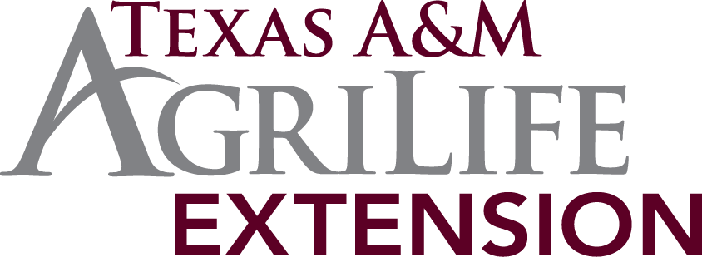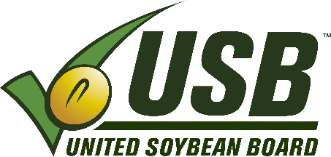
Present
Thursday December 11, 2014
Noon to 5:00 PM
Workshop on Using the Internet To Grow Aquaculture Sales

The Internet and social media are becoming increasingly important as inexpensive marketing and sales tools, but many aquaculture producers and support industries including pond and lake management companies that offer stocking, processors, retailers, and wholesalers, are hesitant to use electronic media. The National Aquaculture Association (NAA) and Texas A&M AgriLife Extension Service are offering an intensive five-hour workshop, “Using the Internet to Grow Aquaculture Sales”. The workshop will provide aquaculture producers and support industries with the knowledge and skills to use electronic media to showcase their products more successfully, grow their businesses, and help shape the public perception of aquaculture. An Internet presence is important for all sectors of the aquaculture industry including foodfish, shellfish, baitfish, feed producers, sportfish, aquatic plants, and equipment suppliers.
For more information, contact Todd Sink, Aquaculture and Fsheries Extension Specialist, at Todd.Sink@tamu.edu or 979-862-1558.

To register, fill out the workshop registration and internet worksheet at http://fisheries.tamu.edu/events/ and e-mail to Todd.Sink@tamu.edu.

Registrations must be completed and received by December 1, 2014.

The majority of the workshop will be devoted to development of individual producer/company websites. A website is substantial method to reach new buyers, strengthen relationships with existing buyers, and promote new or existing products and services at either minimal or no cost. At a minimum, it is a way to let potential buyers that your business exists and where it is located. Producers are asked to preregister for the program and complete a pre-workshop form that will provide critical
information for inclusion on their websites. The NAA will provide some boilerplate information that can be added such as recipes, safe handling, etc. Experts from the NAA will be on hand to help aquaculture professionals with easy to understand click-by-click construction. The Texas A&M University Wildlife and Fisheries department will be providing a state of the art computer lab and a smart board to demonstrate instructions. Space is limited to 18 participants (computer stations) and a few (3-4) supplemental laptops will be available to increase capacity. Attendees are encouraged to bring their own laptops so that we may accommodate more individuals, and they can quickly access their own photos, materials, information, etc.
Both forms must be received in order for registration to be complete. Please indicate if you will be bringing your own laptop.

The workshop will be held December 11th in Room 302, Nagle Hall on the Texas A&M University Campus in College Station, TX.

Parking will be in the University Center Garage accessible from Houston or Throckmorton Street off George Bush Drive. Direct flights on Delta and United are available to Easterwood Airport located adjacent to campus.

Several hotels are available in the area with the Four Points by Sheraton being the closest to the workshop location. Rooms at the Four Point start at $79 per night.

Other social media tools such as Twitter, LinkedIn, and Facebook will also be explored. Times are changing, and there are new marketing and sales strategies to keep pace with an increasingly technology oriented population. Facebook makes it easy to post new information, photos, and events. Twitter is a way to remind your customers and future customers about your products. LinkedIn helps you grow your identity. These strategies are out there and they are free!

Space is limited to 22 registrants (unless more people provide their own laptops), so register ASAP! Here is the best part, thanks to the dedicated efforts of the NAA, support from the United Soybean Board, and hosting and technology support from the Texas A&M AgriLife Extension Service, the workshop is completely FREE for participants!

For information, contact: Todd Sink, Texas A&M AgriLife Extension Service Aquaculture and Fisheries Extension Specialist at Todd.Sink@tamu.edu or 979-862-1558 or Linda ODierno with the National Aquaculture Association at Linda@thenaa.net or 914-330-7678.

To register, complete the registration and internet worksheet forms available at http://fisheries.tamu.edu/events/ and submit by e-mail to Todd.Sink@tamu.edu.
Do not miss this exciting opportunity!

